Provider CCAP Billing Basics
The Division of Child Care (DCC) approved Provider Child Care Assistance Program (CCAP) Billing Basics training must be completed before receiving CCAP payments and yearly thereafter during the fiscal training year, July 1-June 30. Training is updated yearly to focus on important CCAP information and must be taken if there is a change in director or staff submitting CCAP billing. Each staff person is required to set up their own KYID account and have KICCS (Kentucky Integrated Child Care System) portal access. Log in information should not be shared. The free Provider CCAP Billing Basics training can be found on the University of Kentucky’s Human Development Institute’s webpage under Early Care, Education, & Intervention training ECE 080.
This training document is designed to introduce the Child Care Assistance Program (CCAP) billing and reimbursement process to new and existing child care providers. Please keep as a reference when questions arise. If the answers cannot be found in the document, email the Provider Payments inbox for assistance.
When contacting DCC with questions about specific enrollments, email the Provider Payments inbox include your license number, case number for the enrollment in question (or name and date of birth (DOB) of child), and a brief description of the issue. "Send a new email for new inquiries, using old email chains can create issues when tracking down shared information. When sending an email, fill in the subject line prior to sending, the subject can be your CLR#, the case #, or a few words regarding the issue such as “Missing Notices”. Send all inquiries to the CCAP inbox-not specific DCC staff. DCC staff do assist with specific counties and most likely your email will be handled by the same staff person but for tracking purposes, utilize the CCAP inbox.

Provider Portal
Providers are advised to open a KICCS Provider Portal account through the KYID system. Access to the Provider Portal is necessary for many actions required by DRCC (Division of Regulated Child Care, aka Licensing) and is the fastest and most efficient way to submit CCAP billing for reimbursement. A Provider Portal agreement and a KICCS User Guide can be found on the KICCS Provider Portal launch site or by contacting the Portal Access inbox. It is advised that more than one staff person have access to the Provider Portal as a safe guard for accessing or submitting information. When staff who use the portal leave the workplace, notify the Portal Access inbox to have their access removed.
Tip sheet for KICCS Provider Portal Navigation

Who to contact: Family Support or Division of Child Care?
CCAP provides payment assistance for child care costs on a sliding income scale for eligible families, allowing them to gain employment and remain employed. Eligibility for CCAP is administered by the Division of Family Support (DFS). The Family Support office is responsible for working with parents through the application process and ongoing case maintenance. Family Support takes care of all case-specific paperwork, like eligibility verifications and CCAP certificates, in the Kynect system. Eligibility for CCAP is based upon the family’s gross monthly income, family size and their ability to meet all technical eligibility requirements.
Tip sheet for CCAP Eligibility requirements
The DCC CCAP Payment Section is responsible for CCAP subsidy reimbursement and working with child care providers concerning issues related to the CCAP payment. DCC handles the child care provider subsidy information found in KICCS such as CCAP payments, rates, enrollment fees, banking information, and assists providers with questions related to payments. As a courtesy, DCC offers the service of reviewing a CCAP case for the status (approved, denied, discontinued) and enrollment issues related to the payment. DCC doesn’t change enrollments or make any case corrections. Cases can be sent to Family Support staff to review or make corrections. DCC staff cannot share confidential case information with child care providers. The CCAP case is the responsibility of the parent to maintain with the assistance of Family Support.
Child Care providers should not advise parents to contact DCC or the Provider Payments inbox with questions. Parents must contact the Family Support office at 855-309-8959 or visit a local DCBS Family Support office. Child Care providers are advised not to contact the Family Support office for CCAP issues unless they are an authorized representative on the specific case. Family Support works with the parent and DCC works with the child care provider.

Initial and Ongoing CCAP Subsidy Paperwork
After a new child care provider is assigned a license number by DRCC, they must contact DCC to set up a subsidy profile in the KICCS system. A New Provider Packet will be sent with all relevant information for the CCAP program. A Licensed or Certified Provider Agreement Form (DCC-94B) and W9 should be submitted yearly to confirm the information in KICCS is correct and up to date. The KICCS system houses 3 different addresses for providers: physical, mailing, and payee. The mailing and physical addresses are added to the system by DRCC and verified with the DCC-94B while the payee address is found on the W9. To receive the update packet, email the Provider Payments inbox. To update CCAP rates and other information, a current Provider CCAP Billing Basics training certificate is also required.

The Two E’s of CCAP
There are two (2) parts to a CCAP case which must be completed before a child care provider can receive a CCAP payment:
Eligibility-The family must complete the application process with Family Support to determine eligibility; and
Enrollment-The child care enrollment must be added to the approved CCAP case generating a certificate requiring signatures from the parent and the provider.
DCC nor the child care provider have any control over the eligibility part of the CCAP process. Eligibility is the responsibility of the parent and handled by Family Support. Child Care providers should only be concerned with the latest documents sent for enrollment. If the last document received is a discontinuance letter, then CCAP enrollment is not active.
A CCAP case will be approved or denied within thirty (30) days of the date the parent begins the application. A family has thirty (30) days from the date the application is started to return all requested verifications to the Family Support office. If approved, the parent receives a Child Care Approval Notice (DCC-94.1). This notice details the start date of approval, eligible children and copay amount. An approval notice does NOT mean enrollment has been added to the case. It means that enrollment MAY be added.
A CCAP case may be approved without enrollment being added, which prevents the provider from being paid. It is the parent’s responsibility to communicate their child care provider choice, start date, and needed care schedule to the Family Support office. During the application process Family Support will ask the parent to verify enrollment information. If the parent already knows the information, Family Support will add it to the case and upon approval, the certificate will be sent out. If the parent doesn’t know the child care provider information during the interview it is the parent’s responsibility to contact Family Support and provide the information. When a case is approved without enrollment a Child Care Provider Selection reminder (DCC-208) will be sent out. If enrollment is not added within 70 days of the approval date, a Child Care Enrollment Reminder (DCC-209) will be sent to the parent. When Family Support receives enrollment information, they will enter it into the system which will generate the 3- paged Child Care Service Agreement and Certificate (DCC-94).

Steps for Establishing Enrollment
- When a CCAP case becomes approved, the parent will receive a, Child Care Approval Notice (DCC-94.1). This does NOT mean that enrollment has been established or that payments will be made, only that the case is approved for CCAP services.
- CCAP payments cannot begin until enrollment is established.
- To establish enrollment the parent must notify Family Support of their provider choice, a start date for the enrollment, and the care schedule needed. Once Family Support adds this information to an approved CCAP case the system will generate a Child Care Service Agreement and Certificate (DCC-94) overnight. The certificate will be sent to the parent via their preferred communication method, go out in the mail to the parent and appear in the provider portal if portal consent was given by the parent.
- Once generated, the 3-page signed certificate is due back to the Family Support office within 10 days of the date at the top right-hand corner of the certificate (generation date). Ultimately, parents are responsible for making sure the 3-page signed certificate is returned to Family Support.
- A certificate can be mailed, faxed, hand delivered, returned through the KICCS portal, or returned through the parent portal. Either portal is the most efficient method, as once uploaded to the portal, it is sent directly to the digital case file for that specific case. Return information is printed on the DCC-94 certificate. Portal issues do not waive the DCC-94 certificate due date, the parent is ultimately responsible for ensuring the DCC-94 certificate is returned timely.
- Once the certificate is returned, it becomes a processing task for Family Support staff to work. If all 3 pages are returned and signed by the parent and provider, the enrollment will be changed from pending to active in the case. This process generally takes 3-5 business days from the date the certificate was returned to Family Support.
- An Enrollment Approval Notice (DCC-117) will be sent to the provider after the enrollment is made active.
- The DCC-117 lets the provider know the enrollment is active and CCAP payments will be made. If a DCC-117 is not received a few days after the certificate is sent to Family Support, email the Provider Payments inbox for a follow-up.
- It is a business decision to allow a child to attend without an established enrollment because CCAP payments are not guaranteed until the enrollment is established.

DCC-94 – Child Care Service Agreement and Certificate
When child care enrollment is added to a new case or there is a new eligibility period for a case, a Child Care Service Agreement and Certificate (DCC-94), will be sent to the parent and the provider through the provider portal IF the parent granted Provider Portal access during the interview process. The DCC-94 shows the child’s pending enrollment, along with other valuable information. Please review certificates for:
- Child’s schedule
- State reimbursement rate
- Provider payment
- Family copay
- Start and end date of enrollment
- If the Special Needs or Non-traditional hours boxes are checked
A provider needs to be aware of the child’s eligibility end date on the certificate because a notice will not be sent to the provider when the end date is nearing. An enrollment that does not have any changes during the twelve (12)-month eligibility period uses the dates on the certificate as notice of end of care. A Provider Notification Letter (DCC-94C) is only sent ten (10) calendar days prior to an enrollment ending if the enrollment is ending during the twelve (12)-month certification period. When a parent makes a request to change their child care provider enrollment, a ten (10) calendar day notice (DCC-94C) is sent to the current provider to ensure collection of any outstanding payments. The ten (10) calendar day notice is built into the provider change process to protect the current provider and allow them time to collect any monies owed.
Before signing certificate, discuss with Parent:
- Enrollment start/end date
- Enrollment schedule
- Copay amount to be paid weekly
- Overage amounts (difference between the State Max Rate and what the program charges daily. Overages are not printed on the form as they are unique to each child care program and are the responsibility of the child care provider)
If any of the information on the certificate is incorrect, DO NOT sign and return the certificate. When both parties sign and return the certificate, this means BOTH agree with the information on the certificate. It is the parent’s responsibility to contact Family Support for corrections to the certificate. DCC staff cannot change the certificate information.
The certificate must be signed by the provider and client and returned to DCBS Family Support or uploaded to the Provider Portal within ten (10) calendar days of being generated. Payments cannot be made until the signed certificate is returned. The parent applied for CCAP services, and all case information is their responsibility. If changes need to be made, the parent is the only party who can make these changes.
Allowing a child to attend without an established enrollment is a business decision. DCC advises not allowing a child to attend without an established enrollment as CCAP payments are not guaranteed. The eligibility and enrollment process is the parents’ responsibility to complete with Family Support. Providers may contact DCC only to check on a case status and enrollment.
If the parent has questions about the certificate, the parent will need to contact Family Support by calling, 855-306-8959 or by visiting a DCBS Family Support office.
If a child care provider has questions about a certificate, email the Provider Payments inbox or call DCC at 844-209-2657. When contacting DCC, provide your license number, the case number, and a brief description of the issue.
Tip sheet for CCAP Certificates

Schedules
There are two (2) types of child care enrollment schedules: (Flex schedule has been retired)
- The regular schedule is used most frequently. The child requires a consistent and predictable care schedule. For example, care is needed 5 days per week Monday through Friday. A regular schedule may also involve a variety of different days and/or full days (5 or more hours per day; FD) or part days (under 5 hours per day; PD). For example, every week the child needs care Mon-Wed FD and Tue-Thurs PD.
- The school schedule is geared toward children who are of primary school age. It allows full days when school is not in session for prescheduled breaks or summer and part days when school is in session. DCC staff research each district’s school calendar and enter them into KICCS prior to the beginning of the school year. The only time a school age child should NOT be on a school schedule is if the child requires more than 5 hours of care per day or requires non-traditional hours.
Schedules are prefilled on the billing forms with 1 or 2 according to the care schedule on the certificate. If the care schedule is wrong, the payment will be wrong. Therefore, it is important to review the entire certificate with the parent before signing.
If a parent needs to make a change to the care schedule, they need to contact Family Support as soon as possible. Changes to a care schedule are not retroactive therefore the payment will be incorrect if the parent waits until after the change has occurred. Changes are common when a preschool child moves to kindergarten. Children who attend a preschool program part day Monday-Thursday and attend a CCAP program part day Monday-Thursday and a full day on Friday, need to have a care schedule of part days Monday-Thursday and full day on Friday at the CCAP center. If the care schedule is incorrect, the parent needs to be advised by the child care provider to contact Family Support to change it. If the parent doesn’t change the care schedule it is the provider’s responsibility to code the PBF correctly to prevent overpayments. If a change is not reported timely incorrect payments are processed resulting in underpayments or overpayments; that will be recouped.

Returning the Certificate
To receive CCAP payments the DCC-94 (certificate) must be signed by the provider and parent, then returned to the Family Support office within ten (10) calendar days. Once returned a Family Support worker will process the certificate by changing the enrollment from pending to active in the system. Changing the enrollment from pending to active will signal to the system to send out an Enrollment Approval Notice (DCC-117) to the provider.
*Note: Each DCC-94 generates with a unique enrollment ID number. When returning a DCC-94, it is important that the correct enrollment ID number is on each page before it is submitted to Family Support
Return the ENTIRE three (3)-page Certificate by:
- Upload to the KICCS Provider Portal (fastest and most efficient)
- Parent upload to Kynect (fastest and most efficient)
- Fax to 502-573-2007 (keep the fax transmission sheet for verification of dates and success of transmission): This is a Family Support Fax number-not DCC
- Hand deliver to the local DCBS office
- Mail to: DCBS
PO Box 2104
Frankfort, KY 40603
When uploading documents, if you do not have access to a scanner, it is best to use the Scan function found on most phones instead of taking a picture. The scan function is found in the Notes app on an Apple product.
DCC does NOT accept CCAP certificates as these are case-specific documents that must be returned to the case via a portal or one of the above methods to Family Support.
Tip sheet for returning a CCAP certificate.
*Keeping a copy of all pages of the certificate for the provider’s records is useful if the certificate is lost in the mail or not all pages are received through the fax. Retaining a copy of the fax transmission sheet to guarantee number of pages faxed, date, and time faxed is also advisable.
**Allowing children to receive care without a signed certificate is a business decision the provider may make. Please remember, CCAP payments are not guaranteed until a certificate has been signed, returned to the DCBS Family Support office, and entered in the system (which completes the enrollment process) and a Provider Enrollment Approval Notice (DCC-117) has been received.

What happens if the DCC-94 (Certificate) is NOT returned within ten (10) calendar days (untimely)?
If the complete 3-page certificate is not signed and returned timely, CCAP cannot reimburse for care provided and the enrollment could be denied. On the 10th day after the certificate is generated if the complete 3-page certificate has not been returned a Child Care Reminder Notice (DCC-118), will be sent to the parent. The DCC-118 gives a due date of ten (10) additional calendar days and states if the certificate is not received in the next ten (10) additional calendar days the enrollment will be denied, and the parent will be responsible for any charges incurred.
If a certificate is not returned by the 20th calendar day after being generated, the enrollment is denied, and an Enrollment Denial Notice (DCC-119) is sent to the provider alerting them the enrollment denied.
If all three (3) pages of a signed certificate are returned untimely (after the 20th day and the enrollment has been denied), per CCAP policy, the enrollment is added back into the system with the date the untimely certificate is received by the Family Support office.
For example, if an enrollment is added and a certificate is generated on 6/1, it is due back to the Family Support office by 6/11. If not received by 6/11, the system sends out a DCC-118 to the parent giving an additional ten (10) days (6/21) to return the untimely certificate. If the certificate is not returned to the Family Support office by 6/21, the enrollment denies and a DCC-119 is sent to the provider. If the certificate is returned to the Family Support office after the enrollment denied a new enrollment will be added with a new start date of the date the untimely certificate was returned. In the previous example the enrollment denied on 6/21 but if the certificate was returned on 6/28, then the new enrollment start date would be 6/28. The parent is responsible for any days not covered on the new certificate.

What happens when the DCC-94 is returned incomplete?
When the DCC-94 is returned incomplete, the enrollment is marked as incomplete certificate received. A certificate is considered incomplete if:
- Either required signature is missing.
- Any of the three (3) pages are not returned.
- If the enrollment ID number on the DCC-94 does not match all three (3) pages.
When the enrollment is marked as an incomplete certificate received, a Notice of Incomplete Certificate (DCC-095) is generated and sent to the provider and the parent. The enrollment record will not be denied unless the DCC-94 is not received timely. If the initial ten (10) day due date passes, without a complete DCC-94 being received, a Certificate Reminder Notice (DCC-118) will be sent to the parent notifying the certificate has not been returned. The system will allow an additional 10 days to return a complete DCC-94 without the enrollment denying.

What happens when the DCC-94 is returned correctly?
When the DCC-94 is returned timely and all three (3) pages are signed, the enrollment is marked as active in the system by Family Support. The day after the enrollment is marked active, an Enrollment Approval Notice (DCC-117), is sent to the provider through the Provider Portal or via mail. This notice alerts the provider that the enrollment is now approved and ready for payments to begin.
If you believe that the DCC-94 was returned timely and you received a DCC-119, Enrollment Denial Notice, email the Provider Payments inbox. When contacting DCC provide your license number, the case number, and a brief description of the issue. The parent can contact the Family Support office to check on the certificate status.

DCC-117 and DCC-119
After a 3-page signed certificate has been returned to Family Support and the enrollment becomes active, the system will send a DCC-117 Enrollment Approval Notice to the provider. When enrollment is denied because the 3-page certificate was not returned, the system will send a DCC-119 Enrollment Denial Notice to the provider. If more than one child in the family is receiving CCAP, it is important to check that all children are listed on the DCC-117 (Approval Notice) and the DCC-119 (Denial Notice). If all children are not listed, not all enrollments were marked active or denied. If a certificate is returned and the provider doesn’t receive the DCC-117 in a few days or not all children are listed, the provider can contact the Provider Payments inbox. If a DCC-119 is received unexpectantly, it is advised the provider to contact the Provider Payments inbox.
*An active CCAP enrollment means an Enrollment Approval Notice, DCC-117, has been received by the provider.

Notice of Change Certificate
Providers will receive the Notice of Change Child Care Service Agreement (DCC-94), if the copay increases/decreases, the child’s care schedule changes, or if any rates change. The changes are at the top of the certificate for easy reference. No signatures are required; this is for information and record keeping purposes only. Signatures are only required on a certificate of application, recertification (unless nothing changes on the certificate) or with a provider change.

DCC-94C Provider Notification Letter and Enrollment End Date
If the child’s enrollment is being discontinued for any reason during the twelve (12)-month eligibility period (before the end date on the certificate), a Provider Notification Letter (DCC-94C), will be generated. The effective date on the DCC-94C is the first day of non-payment. If an enrollment does not have any changes during the 12-month eligibility period, the end date on the certificate serves as the notice and a DCC-94C will not be sent.
A DCC-94C will be sent to the provider if a CCAP case ends because of a change in the case, making the family ineligible. A DCC-94C is sent to the child care provider ten (10) calendar days prior to the effective date on the letter. If during ten (10) calendar days the parent contacts the Family Support office to resolve the issue a Notice of Change Child Care Service Agreement and Certificate, DCC-94, will be sent to the parent and the child care provider. As a provider, if you receive a DCC-94C and do NOT receive a follow up DCC-94, then the case has discontinued and CCAP payments have ended. Frequently parents will tell providers that the issue has been resolved but unless a Notice of Change Certificate has been received, it is best to contact the Provider Payments inbox to double check on the enrollment.
If the CCAP case does not have any changes that affect the end date of the twelve (12)-month eligibility period, the end date on the certificate serves as the provider’s notice of discontinuance. If there are questions, the parent will need to contact Family Support (855-306-8959) to discuss specifics of their case. Providers may contact DCC with questions concerning payments or certificates at the Provider Payments inbox or 844-209-2657. Due to confidentiality, DCC staff cannot communicate the reason for the discontinuance with providers. Staff may only discuss the information that is on the certificate and the status of the case. Any other concerns or questions will require the parent to contact Family Support. Family Support staff are unable to discuss CCAP cases with child care providers.
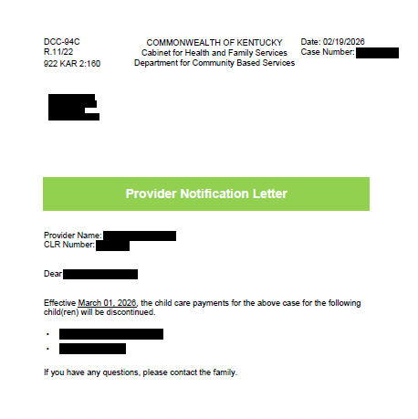

Payment Rates and the DCC-94B
The DCC-300, Kentucky Child Care Maximum Payment Rate Chart details the max rate by county the state can reimburse per child based upon license type and age of child. Rates are based on a full day, which is defined as five (5) or more hours per day or part day, which is defined as less than five (5) hours of care per day. The state of Kentucky does not mandate the rates a provider can charge. Each provider may consult the DCC-300 when setting their rates but ultimately may charge more or less than these rates. Providers are encouraged to complete a DCC-94B, Licensed or Certified Provider Agreement Form and W9, yearly. The DCC- 94B allows providers to make billing changes and update other important CCAP information in the KICCS system that may affect CCAP payments. A Provider Update packet can be requested by contacting the Provider Payments inbox.
Child Care programs may receive an add-on rate in certain situations. Add-on rates (if applicable) are added at the time of payment through the KICCS system and are not reflected on the State Max Rate DCC-300.
Families are responsible for:
- Copayments
- Registration/Enrollment fees
- Overages
- Activity fees
- Transportation fees
- Any other charges required by the provider not included in the daily rates
CCAP payment rates are determined by the age of the child and change on the child’s birth date. The chart below outlines the age and the corresponding code used in the system. Please note, a Preschool 3 (PS3) age child could be in kindergarten or still attending a preschool program. The rate will be the same regardless of what type of program the child is attending as it is based on age only. Children attending Kindergarten must be on a school schedule.
Age | KICCS Code
Birth through 12 months | Infant 1 (IN-1)
1 to 2nd birthday | Toddler 1 (TD-1)
2 to 3rd birthday | Toddler 2 (TD-2)
3 to 4th birthday | Preschool 1 (PS-1)
4 to 5th birthday | Preschool 2 (PS-2)
5 to 6th birthday | Preschool 3 (PS-3)
6 to 8th birthday | School age 1 (SA-1)
8 to 13th birthday | School age 2 (SA-2)
13 to 19th birthday | School age 3 (SA-3)
A provider cannot charge participants in CCAP a higher rate for child care than what is being charged to the public.

Copays
The family copay is assigned to the case during the application process and is added to the CCAP certificate generally attached to the youngest child in the household. Copays are based on the size of the household and household income. The CCAP certificate details the payment information with the start/end date of care, care level, the Provider Rate (full and part day), the daily copay, the Daily CHFS Payment (full and part day), and the Scheduled Days of care.

Enrollment A
This child is not approved for special needs or non-traditional hours. The care start date is 1/1/26 until 12/31/26. The child is a Toddler 1 from 1/1/26-12/5/26 and a Toddler 2 from 12/6/26-12/31/26 with a Full day rate of $47 per day and a part day rate of $43 per day. A daily copay of $13 is assigned. The Daily CHFS Payment is $34 for a full day and $30 for a part day. The child is scheduled for 5 full days per week.
The daily rate is the total of the copay plus the CHFS Payment. $13 (copay) + $34 (CHFS) = $47 (daily rate).
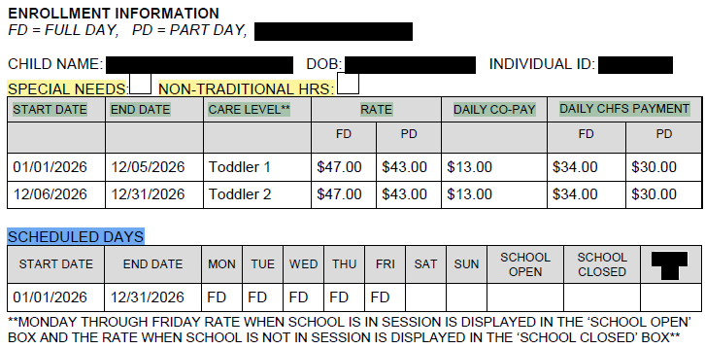

Enrollment B
This child is not approved for special needs or non-traditional hours. The care dates are 8/8/25 until 08/31/26. The child is a School Age 1 from 8/8/25-8/31/26 with a Full day rate of $37 per day and a part day rate of $16 per day. A daily copay of $9 is assigned. The Daily CHFS Payment is $28 for a full day and $7 for a part day. The child is on a regular school age schedule for part day when school is open and full day when school is closed.
The daily rate is the total of the copay plus the CHFS Payment. $9(copay)+ $28(CHFS) = $37(daily rate).
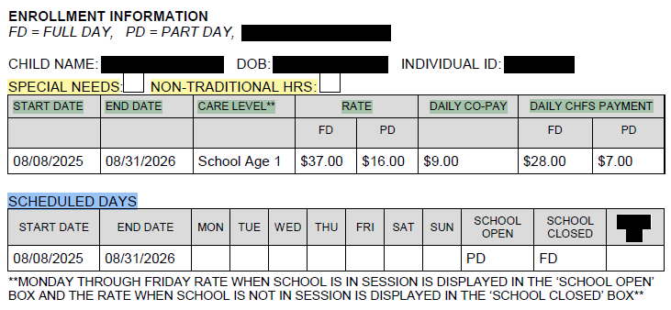
The parent is responsible for paying the family copay. As a business owner, child care programs can decide how to handle the copay process. Some require a weekly payment, and some do not collect at all. It is best business practice to not allow parents to fall behind in the copayment just as private pay families are not allowed to fall behind in tuition charges. When a parent decides to change the child care enrollment to another provider, a ten (10) calendar day notice (DCC-94C) is built into the change process to allow collection of any outstanding copayments. DCC is not involved in the collection of copayments.

Overages vs Copays
An overage and a copay are different things. A copay is assigned to the family during the eligibility process based on the household income and family size then printed on the CCAP certificate. Overages occur when the provider charges more than the State Max rate for the area. For example, a provider charges $30 per day but the State Max Rate is $25 per day. This means there is a $5 per day overage. The parent is responsible for paying the overage in addition to the assessed copay found on the child care certificate. The overage is not printed on the certificate because by regulation CCAP only considers the State Max Rate and not individual program rates. An overage is unique to each program and can include extras such as special add-on classes, excursions, and discounts for multiple children. It is the business responsibility of the provider to explain to the parent the overage as it relates to their daily rates. The possibility of overage is explained by Family Support during the interview process and on the DCC-94Sup, Understanding the Child Care Service Agreement and Certificate given to the parent when enrollment is added to the system. It is possible that a family will have an overage but not have a copay assigned by family support. Copays are not based on the provider’s tuition rates or other fees associated with the cost of care. DCC is not involved in the process of collecting the overage. It is the provider’s financial responsibility as a business owner to maintain the overage and copay collection. DCC advises providers to go over the copay and any overages with the parent upon signing the certificate.

Overage Calculation Example
If a provider charges $50 per day for an infant and the State Max Rate is $40 per day, there is an overage of $10 per day. CCAP/CHFS pays $40 per day, and the parent pays the overage of $10 per day to equal $50 per day. ($40 + $10 =$50)
If the provider charges $50 for an infant and the family has a $5 copay, and the State Max Rate is $40 then CCAP/CHFS pays $35 per day, and the parent pays $5 per day copay and the $10 per day overage for a daily parent responsibility of $15 per day. ($35 + $5 +$10 =$50)

Attendance Records
A DCC-94E, Child Care Daily Attendance Record or a cabinet approved electronic billing system (Brightwheel, see below) daily attendance record, is required for all providers (licensed, certified, and registered). Each child’s name needs to be listed legibly on the DCC-94E exactly as listed on the certificate. The parent, guardian, authorized representative, or program staff need to record the actual time the child arrives and departs daily and initial the form. DO NOT record this information in advance. To verify accuracy of attendance, the parent/guardian, or authorized representative must legibly sign the form at the end of each week, if signature is not legible must print first/last name above or below the signature. The provider must legibly sign the form at the bottom of every page of the DCC-94E and on the Brightwheel electronic form. If signature is not legible, you must print first/last name above or below the signature. If the DCC-94E or Brightwheel forms are not correctly filled out CCAP funds may be recouped by DCC. The Provider Billing Form (PBF), DCC-94E, and/or Brightwheel records should be compared to ensure the child’s attendance has been recorded and billed correctly. The DCC-94E and/or Brightwheel records must be kept for five (5) years for each child. Providers must submit the DCC-94E or Brightwheel records if requested by the cabinet. If not, the CCAP payment may be placed on hold until the records are received by DCC Claims staff. Failure to comply with this request may result in CCAP payments being suspended until all requested records are received by DCC. Find a fillable version of the DCC-94E on DCC’s website.

Electronic Attendance Records
The Division of Child Care (DCC) has selected brightwheel as the only approved childcare management software for licensed and regulated programs across the state. Not only can you receive brightwheel entirely free through DCC, but brightwheel electronic attendance records are accepted during licensing visits.
Learn more and claim your FREE brightwheel subscription through their 12.
Email brightwheel for questions about your account or support to get started.

Timeframe for Receiving CCAP Payments
The DCC-97, Provider Billing Form (PBF), is generally open to providers on the first day of each month. There is no guarantee of a specific time or date the PBF will open but the goal is the first day of the month. Providers who use the KICCS Provider Portal can access and submit their billing electronically. Providers who do not use the Provider Portal will receive their paper PBF in the mail which is mailed on the first business day of the month. Paper PBFs may be returned to DCC via email to the Provider Payments inbox, mailed using the address on the form, or faxed to 502-564-3464.
The PBF is auto-processed overnight on the day it is submitted by the provider. Auto-processing means DCC staff do not review each child on the PBF before the payment is processed and Provider Notes are not reviewed to make corrections. If PBF needs to be corrected send an email detailing the correction to the Provider Payments inbox.
After being processed in the KICCS system the PBFs are sent to Treasury to dispense the funds. DCC doesn’t issue a direct deposit or paper check for a regular CCAP payment. Kentucky Administrative Regulations and DCC CCAP Policy govern that PBFs are processed within ten (10) business days of receipt. Providers that have inquiries about the timeframe for payment should reference Kentucky Revised Statutes Chapter 45.453 which states, Providers shall receive payment within thirty (30) working days of processing the PBF, except when there are payment discrepancies in the payment amount billed and the amount owed to the provider. In these instances, the Cabinet is not held to the thirty (30) day period for payment.
Provider payments are issued in the form of a check unless the provider chooses to receive the payment as an electronic direct deposit. Direct Deposit is recommended as it is faster and more efficient. To set up direct deposit a provider must submit a DCC-93, Authorization for Electronic Deposit and a W9. A DCC-93 and W9 can be requested by contacting the Provider Payments inbox. Payment options may be changed a total of three (3) times within a calendar year unless there is a change in provider type or license number.
CCAP reimbursement payments are generally received by direct deposit within 3-5 business days (can take longer depending on Treasury, holidays, etc....) from the date the PBF is submitted by the provider. A paper check will take up to 15 business days to be received. Holidays and weekends will also affect the length of time it takes to receive payment. PBFs submitted on Fridays are not processed until Sundays and then go to Treasury.
Tip sheet for Printing a PBF for records

Blank Paper PBF
The form below is a blank paper DCC-97 form. The form includes the children’s names and care schedule from the current certificate prefilled on the ‘Scheduled’ line.
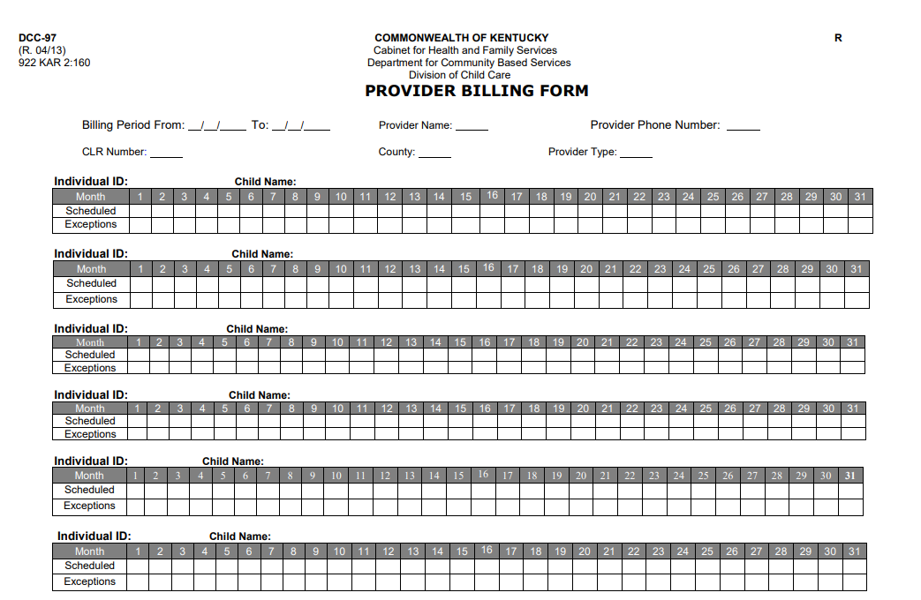

Provider Portal PBF
The portal PBF below is filled out for April 2026 and was available to be submitted by the provider on May 1, 2026. The child’s care schedule from the DCC-94 certificate is prefilled on the ‘Scheduled’ line. The PBF shows the Care Level for the child which is determined by the child’s age and may change during the month if the birthday falls during that month. The Codes being paid are from the prefilled schedule, the provider exception line, or both. The Count is the number of days being paid for each code. The Rate is what the provider charges per day for that care level (or the State Max Rate) and the copay rate. The form has the daily calendar available for billing for each day the child is scheduled to attend in the month of April with lines for Provider Exceptions and Worker (DCC staff) Exceptions. The exception codes are under the calendar boxes.
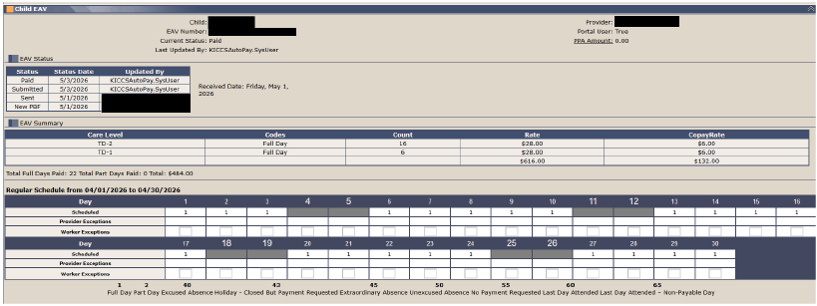

Coding the PBF
CCAP reimburses based on the enrollment of the child and not the occasional absences of the child. This means codes 40, 45, and 50 should not be used when submitting the PBF. CCAP enrollments may miss more than 5 days per month (code 40 Excused absence of 5 per month), Extraordinary absences (code 45 absences exceeding 5 per month for illness, death in family, natural disaster), and Unexcused absences (code 50 undocumented absences) should not be recorded on the PBF.

Center Closures
CCAP will reimburse for days that illness causes a center or individual room closure and for weather due to a sudden regionwide event and/or State of Emergency. However, if a center closes for other reasons, (holiday, vacation, or training) the PBF must be coded with a code 43 or code 55. Each calendar year each center is allotted 10 code 43s to be used at the business’ discretion for center closures. Code 55 is ‘no payment requested’ and used if all 10 code 43s have been exhausted.
When submitting the PBF the ONLY Exception codes to be used are as follows:
- 1= Full Day
- 2= Part Day
- 43=Holiday Code (10 allowed per Calendar year)
- 55=No payment requested (to prevent overpayment following codes 60/65, if center is closed other than one of the 10 holidays allowed, or if care schedule is incorrect for child’s needs)
- 60= Last Day Attended (followed by 55s)
- 65= Last Day Attended, Non-Payable Day (followed by 55s)
When the PBF is generated, the prefilled codes will be incorrect if the care schedule on the certificate is incorrect. To prevent this issue do not sign and return a certificate with an incorrect care schedule. The provider is responsible for reviewing the CCAP certificate with the parent before signing and returning to the Family Support office. The parent is the only responsible party who can make changes to the certificate. If a PBF has incorrect prefilled codes it is the provider’s responsibility to code the PBF with the correct codes ensuring the payment is correct. For example, if a provider expects a child to never attend on Friday, but the PBF is prefilled with a code, the provider should code with a 55. The provider is responsible for advising the parent to contact the Family Support office to have the care schedule corrected.

Ending an enrollment
If a child is absent more than 5 consecutive days, the provider is responsible for reaching out to the parent to verify if they will continue to use the CCAP spot. If a child is absent 10 consecutive scheduled days of care the provider should end the CCAP enrollment by using a code 65 on the 11th absent day followed by 55s for the rest of the month. If the family has not used the spot for 10 days, the spot should be open for another child needing care.
If a certificate is issued for a new CCAP enrollment but the child doesn’t start until after the care start on the certificate, the PBF should be coded with 55s until the actual date the child begins attending.

Details of the billing codes are as follows:
Codes 43, 55 and 65 are based on the provider’s circumstance.
Codes 40, and 60 are based on the child’s circumstance.
The exception codes for each provider type are as follows: $= payable code

Licensed Provider
01 -$ Full day-payable code for attendance of five (5) or more hours per day
02 -$ Part Day-payable code for attendance less than five (5) hours per day
43 -$ Holiday, closed but payment requested NOTE: Limit of ten (10) days per year. If provider is closed for holidays more than ten (10) days per year, code 55 must be used for any days over the first ten (10) days. If this code is used on even one child in error the system automatically uses one of the ten (10) holidays for the year.
55 - Closed, no payment requested
60 -$ Last day attended –payable code-follow with code 55 to prevent overpayment
65 – Non-payable code used to end enrollment-follow with code 55 to prevent overpayment. Codes 60 and 65 were designed to give the provider a method of ending an enrollment for a child that is no longer attending the child care center.

Certified Providers $ payable code
01 -$ Full day- payable code for attendance of five (5) or more hours per day
02 -$ Part Day-payable code for attendance less than five (5) hours per day
43 -$ Holiday, closed but payment requested
NOTE: Limit of ten (10) days per year. If provider is closed for holidays for more than ten (10) days per year, they must be shown in code 55. If this code is used on even one child in error the system automatically uses one of the ten (10) holidays for the year
55 - Closed, no payment requested
60 -$ Last day attended –payable day, follow with code 55
65 – Non-payable day used to end enrollment, follow with code 55

Registered Providers $=payable code
01 -$ Full day
02 -$ Part Day
60 –$ Last day attended –payable day, follow with code 55
65 – Non-payable day used to end enrollment, follow with code 55
Codes 60 or 65 MUST follow with 55s to prevent overpayments.

Important Reminders:
- A PBF in a New PBF status is available to submit for ninety (90) days. After ninety (90) days the PBF will be void and can no longer be submitted. A provider may request a PBF may be reset once in a twelve (12)-month period.
- Providers shall receive payment within thirty (30) calendar days.
- Payment or adjustments cannot be made ninety (90) days after the month the care was provided.
- Using correct billing codes helps prevent overpayments.
- A provider may end an enrollment on a PBF using a code 60 or 65 followed by code 55. Code 60 will pay for the last day the child attended, and code 65 will end enrollment without payment.
- Code 43 is for HOLIDAY pay only. If code 43 is used on one child during a billing cycle, the system picks it up and uses one of the center’s ten (10) holidays for the calendar year. During the December billing cycle, providers frequently question why they are out of holidays, and it is generally because a child was coded in the previous month incorrectly.
- Never submit a blank PBF and leave a provider note with directions on how to code the PBF. Coding the PBF is the provider’s responsibility. If you have questions, contact the Provider Payments inbox.

Transitional Child Care/TCC
CCAP families that are discontinued due to combined household incomes exceeding 85% State Median Income/SMI at case change or recertification are eligible for Transitional Child Care/TCC. This is an additional CCAP benefit period lasting 6 months. During the TCC period, the reimbursement rate is reduced to ease the family off CCAP. The parent is notified of CCAP eligibility being based on TCC when the application is approved. The provider will be able to distinguish a TCC case by the rates on the certificate. The rates will be 50% of the provider rates or the State Max Rate if the provider charges more than the State Max Rate and there will be a $0 copay.
What does this mean for you as a provider and how do you identify TCC:
- The copayments are always zero ($0).
- The reduced rate is calculated as 50% of the Provider Subsidized Rate or the State Max Rate (whichever is lower). Example: If the State Max Rate for the child’s care level is $20, during the TCC period, the rate paid by the state would be $10.
- The family is responsible for any overages charged by your program.
- You will receive a DCC-94 - Notice of Change, that outlines the new reimbursement rate and end date for each child. This will serve as your notice of eligibility discontinuance.
- Parents will also receive a Notice of Change showing the new rates being paid by CHFS.
- Normal billing procedures will be followed, and the adjusted rate will be reflected in the Remittance Report.

Child Care Employee Income Exclusion
To receive the Child Care Employee Income Exclusion, child care employees must apply for traditional CCAP. During the interview process the parent should communicate the need for the Child Care Income Exclusion to be added to the case. This will trigger the system to send the Employee Income Exclusion Verification, DCC-207 for verification. The parent can also use a written letter from the child care employer detailing the employment start date, rate of pay, pay schedule, and hours worked per week. This work statement must also include the center’s name, license number, and complete name and contact information for the person signing the letter. Adults in the household must still meet CCAP work requirements, SNAP E&T, and training/education, as well as all other technical eligibility requirements. All existing mandatory verifications still apply and failure to provide these completely or timely would result in denial/discontinuance. If the application is approved ALL household income will be excluded from the case allowing CCAP to reimburse up to the State Max Rate or the provider’s reported rate if less than the State Max.
Employment of a parent/stepparent must be with a CHFS regulated (licensed or certified) child care provider. Children do not need to attend the same center where the parent is employed. Families would still be responsible for any overages assessed by the child care provider, if applicable. The employee must work a regular schedule of at least 20 hours per week in the child care program. All CCAP program rules apply as this is still a regular CCAP case with an exclusion applied. The case will need to be recertified each year timely with all requested verifications returned.
The child care exclusion is not offered to child care center owners. Child Care programs providing care less than 4 hours per day are not open enough hours daily to offer employment of 20 hours per week and will not qualify.

Prior Period Adjustment
A Prior Period Adjustment (PPA) is the process used by DCC billing staff, under certain circumstances, to correct a billing issue. A PPA can only be used if the child has received payments in previous months. The PPA process is handled by DCC staff and doesn’t require the provider or parent to do anything for this process. The remittance statement will verify the PPA payment.
Per, (922.KAR 2:160, 17(g)) payments or adjustments cannot be made to the payment ninety (90) days after the month’s care was provided.

Remittance Statements
A Remittance statement serves as a detailed receipt for CCAP payments. Remittance statements are available the day after the PBF has been processed. Portal users can print their remittance statement from the Provider Portal after the PBF has been processed. Each Monday, DCC will print and mail non-portal users the remittance statement for payments processed the prior week. It is advised to print the remittance statement and keep for records, taxes, and other bookkeeping purposes. DCC is unable to print and send remittance statements for the year as they are made available to each provider either on the KICCS portal or mailed weekly.
The remittance statement provides:
- Detailed payment amount for each child including care level, number of days paid, rates, and copay
- Allow the provider to review the information and determine if the payment amounts are correct monthly
Use the remittance statement to verify CCAP payments monthly and if a discrepancy is found, contact the Provider Payments inbox to report an issue. Waiting more than 90 days after care was provided may be cause for loss of payment. Kentucky Administrative Regulations state that payment adjustments will not be made ninety (90) calendar days after the month’s care was provided.
Tip sheet for Printing the Remittance

Enrollment Fee
Enrollment fees can be paid for teen parents attending elementary, middle, or high school (TENF), Kentucky Transitional Assistance Program (KTAP) or Child Care Protection and Permanency cases approved by DCBS Family Support or DCBS Protection and Permanency. Enrollment fees are only paid for these three groups of recipients. The enrollment fee must be requested by the provider in writing to CCAPProviderPayments@ky.gov. Include the child’s name, case number and the amount requested. Enrollment fees can only be paid once in a twelve (12)-month period and are limited to a family amount of $100 per year.

Tax Details
DCC doesn’t provide 1099 forms for taxes. The Kentucky Finance & Administration Cabinet/ Department of Revenue send out 1099’s yearly. DCC is unable to print or reissue 1099. Contact KY Department of Revenue (502) 564-4581 or Department of Finance and Administration (502) 564-8639.

Intercepts
An interception may occur on a CCAP reimbursement payment if funds are owed to a state agency. Generally, this applies to back taxes, educational loan defaults, CCAP claims, or child support owed. DCC is not involved in the interception process and cannot offer any details, except the amount that was intercepted. DCC is not aware of an intercept will or has occurred until a provider requests information about their payment. If the entire CCAP payment is not intercepted the remainder of the payment will be sent via check to the Payee address on file. Questions may be directed at:
IRS-related intercept information
KY Department of Revenue or (502) 564-458
Treasury Department or 502-564-4722

Common Issues/Questions
- Join the DCCListServ message system by sending your first and last name and email address.
- When contacting the Provider Payments inbox provide the license number, case number and a brief description of the issue. If you do not have a case number, include the parent and child’s first and last name.
- When enrollment ends, especially at the yearly recertification, Family Support does not automatically re-enroll children with the previous provider. The parent must notify Family Support of their provider choice each year.
- If a child is not on the PBF the provider should:
  - Check the end date on the current certificate
  - Check Provider Portal records for a DCC-94C
  - If an answer is still not found contact the Provider Payments inbox
- Explore the DCC website. The website can assist families and providers with finding all things related to DCC and its programs. Specifically, click on Child Care Assistance Program for Providers then click on the KICCS Provider Portal link. Under the Additional Information section, you will find many useful guides and tip sheets.

