Team KY SCOPE (ECHO)
Participant Guide

Team KY SCOPE is facilitated through the Human Development Institute at UK.

WHAT IS The SCOPE ECHO?
Project ECHO™ is an interprofessional practice network where education and/or healthcare professionals learn together. Short instructional lectures and case presentations are conducted during recurring video conferences. Participants learn best practices to support the individuals they serve by implementing real-time solutions, improving systems, and removing barriers to care. This SCOPE series follows the ECHO model.

ECHO Networks provide ongoing support for educators, healthcare providers, and families in a rural state where specialized knowledge is not always locally available. By removing these barriers to specialized knowledge, outcomes for students, patients, and families are improved.

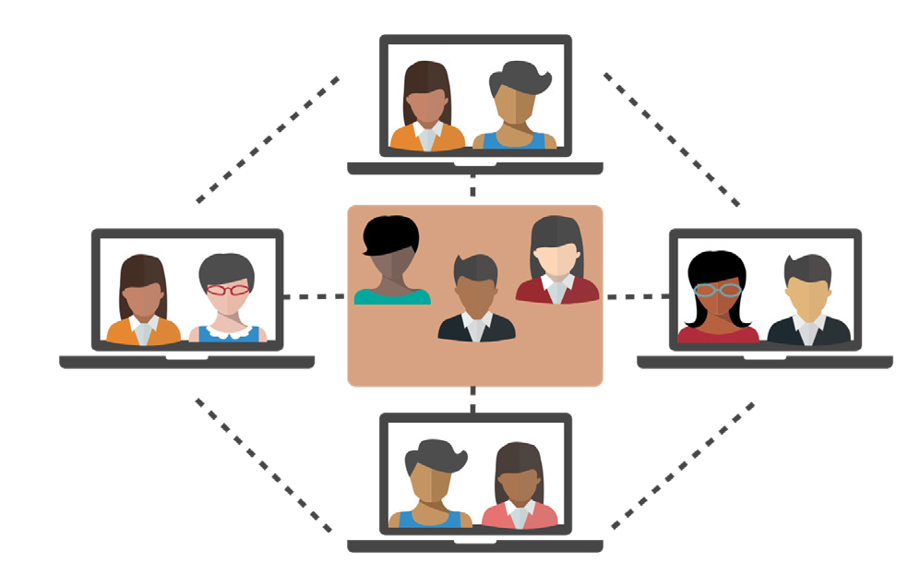ALL TEACH. ALL LEARN.
The heart of the ECHO model is its knowledge-sharing networks, led by expert teams. Case- based learning and mentorship is key to the ECHO model and supports local professionals and communities to gain the expertise required to provide needed services.
Participants gain skills and confidence and learn about new approaches
for applying their knowledge across diverse cultural and geographical contexts.

      - Join sessions online via Zoom
      - Connect through your desktop, laptop, tablet, or phone
      - Join from the comfort of your classroom, office, or home Professional credits are available
      - No cost to participants

STRUCTURE OF A SESSION
- Start Session
  - Zoom room is open 15 minutes prior to session start
  - 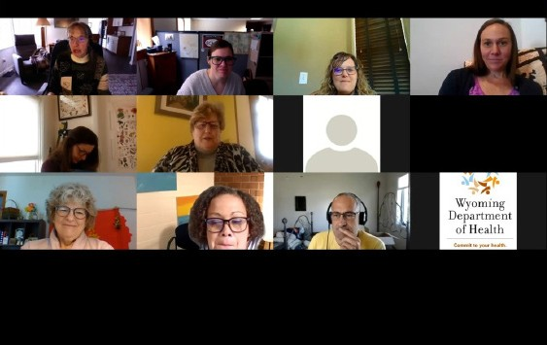Troubleshoot technology with Brandon Cannada

- Introductions and Announcements
  - Facilitators, Expert Presenters

- Expert Presentation
  - 30 minutes or less - Includes time for Q&A

- Case Presentation
  - Case study presented (from participants)
  - Clarifying questions from participants
  - Recommendations, strategies, and considerations discussed
  - Summary of recommendations sent to case presenter following the session

- Final Announcements
  - Upcoming session information
  - Reminder about weekly session evaluation
  - Reminder about where to access materials

SURVEYS, EVALUATIONS, AND INCENTIVES

A pre-series survey will be sent to you before August 25. It is critical that you complete it before the series begins! It will be the longest form you receive. All later surveys will be shorter!

Then, session evaluations will be emailed to you following each session. Please complete each so that we may improve the series! Incentives will be awarded to all persons who attend all sessions! Your input is incredibly valuable in shaping the content and needs of future ECHOs.

ECE-TRIS credit will be awarded upon request. Professional board CEUs must be submitted by the individual participant; we will supply session descriptions, training objectives and speaker information if required.

WAYS TO PARTICIPATE
ECHO is an interactive community: presenters, stakeholders, and community members all communicate and support each other during a session. Participants are expected to be engaged in asking questions after the presentation and to provide feedback for the case.
Case narratives are the best way to solidify skills learned in the presentation and receive directly applicable advice. If you would like to present a case narrative, use the case presentation template in the SCOPE document site.

Contribute to Meaningful Discussions
  - “Thank you for sharing.”
  - “This is relevant to me in the following ways “
  - “Tell me more about the way it affected... “
  - “Tell me more about “

Actively Engage
  - Be ready to learn
  - Reduce distractions
  - Avoid reading/sending messages or doing other work
  - Invite others to attend
  - Use presenter’s prompt or guiding questions

Open Your Mind to Diverse Views
  - Learn from others
  - Adopt the spirit of improving, not proving
  - Value all perspectives
  - Be mindful of who is not in the room

Lead By Example
  - Share your knowledge
  - Share the recorded session with others
  - Your contributions are invaluable

Maintain Confidentiality
  - Follow FERPA and HIPAA protocols

Thank you for:
  - Increasing quality participant engagement
  - Reducing awkward silence gaps
  - Avoiding "sit and get" learning
  - Encouraging professional learning standards
  - Creating a positive experience for all

ZOOM GUIDE
- Click on the Zoom link provided on the series invitation.
- Select “Join Audio by Computer.” You can test the volume of your speaker and mic to ensure they are working by clicking on “Test Computer Audio.”
- A toolbar will appear by hovering over your Zoom window. Some of the features you may use include:

- Mute/Unmute - Mute or unmute your audio. Use the unmute option to enable your microphone during discussions or Q&A. Please leave your audio muted during presentations to minimize background noise.
- Stop/Start Video - Start or stop your video feed. ECHO is an interactive community and we highly encourage participants to leave their video feeds on during sessions.
- Participants - View a list of session participants.
- Chat - The in-meeting chat allows you to send chat messages to other users or the entire group during a session. This feature can be useful in asking questions to didactic or case presenters.
Click on the “Chat” icon. Type your comment or question in the chat box and then hit “Enter”.
- Leave Meeting - Leave the video meeting.

Renaming Your Profile
Please rename your profile to your first and last name, and the organization you represent. This helps our team count you in attendance for professional development credits and helps build our community.
Click the “Participants” icon. Click on “Rename” next to your user name. Rename your profile in the dialogue box. Click “OK.”

How to “Raise Your Hand”
The “Raise Hand” feature is helpful if you have a question for the facilitator or presenter.
Click the “Participants” icon. Click the “Raise Hand” option at the bottom. Once the facilitator calls on you, use the “Unmute” button to enable your microphone and provide your comment.

Accessibility - Zoom provides access for users with physical disabilities, blindness, and low vision through a range of keyboard shortcuts. Additionally, instructions on how to access closed captioning will be given at the beginning of each session.

Tech Support- If you are having any technical difficulties contact brandon.cannada@uky.edu.

