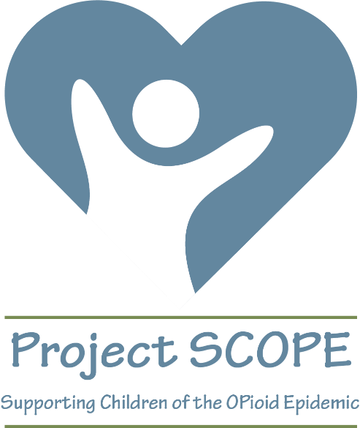 PROJECT SCOPE REGISTRATION FLYER
TEAM KENTUCKY PROJECT SCOPE FALL 2020 TRAINING SERIES
- Purpose: to build capacity of providers serving children, birth to five years, with neonatal abstinence syndrome (NAS) and other substance use disorders and their families
- Participants: open to providers across KY who serve children with NAS and their families
- Funded by the Human Development Institute at UK, the Wyoming Institute for Disabilities, the Nisonger Center at The Ohio State University, and the University of Cincinnati Center for Excellence in Developmental Disabilities
SCOPE SCHEDULE, TOPIC, AND SPEAKERS
- Fall 2020 online series of zoom calls
- 7 calls in all, 1.5 hours each, from 2-3:30pm Eastern time on the dates indicated below
- Alternate Tuesdays, except as indicated (October 27 instead of November 3)
  - Tuesday, August 25 (Introduction to Social Determinants of Health, Dr. Mykal Leslie)
  - Tuesday, September 8 (Addiction and Treatment, Sharon Hesseltine and Maggie Schroeder)
  - Tuesday, September 22 (NAS, Diana Frankenburger)
  - Tuesday, October 6 (Monitoring Child Development, Dr. Jennifer Grisham)
  - Tuesday, October 20 (Having Difficult Conversations, Jason Joy)
  - Tuesday, October 27 (Trauma-Informed Interventions for Families with Young Children, Miriam Silman)
  - Tuesday, November 17 (The Role of Peers for Families in Recovery, Sharon Hesseltine and Kim Hillard)
- Each call includes a 20-30 minute expert presentation on the topic, presentation of a case example, and small group interactive discussion of possible strategies. An electronic discussion board will continue the discussion at providers’ convenience.
- The series is designed for participants to attend all 7 sessions, as we will be developing a community of practice to support each other in serving children with NAS and their families. We’ll have fun incentives for participation!
REGISTRATION PROCEDURES
- Registration opens on Monday, August 10 at 12:00pm Eastern time
- Register at the following LINK: https://uky.az1.qualtrics.com/jfe/form/SV_9zZCQW3iHd6cNNP
- Due to the great interest in this series, the first 60 people will be accepted for this pilot series; a waiting list will be maintained. You will receive an email within 48 hours of registering regarding your acceptance into the training, or your placement on the waiting list.
- There is no cost for the training; certificates will be awarded for full attendance; ECE-TRIS credit is in process.

CONTACT FOR REGISTRATION QUESTIONS
Brandon.cannada@uky.edu

