Levels of Evaluation

- Four Levels of Evaluation……………….pg 3
- Training Improvement Process………...pg 7
- Analyzing Training Data………………...pg 9

Training outcome
Participants will classify evaluation activities into 4 major levels of evaluation.
Participants will submit and evaluation plan for the training they designed during the Face to Face session.
Participants will describe the purposes of the data analysis process and uses for evaluation information.

Participants will select data analysis processes that can inform them about refinement of one of their training sessions.

Participants will apply key data analysis questions in analyzing a training session to determine the level of refinement needed.

Roadmap
- Review the purpose of evaluation.
- Identify some pros and cons of evaluation.
- Explore data collection techniques for evaluating effectiveness of training.
- Discuss the three ways data can be used and how that influences analyzing and reporting the data.
- Identify the four reporting questions that must be asked and answered by the trainer.
- Identify some reflection questions that guide the creation of Evaluation Forms and support the trainer’s self-reflection of the training session.
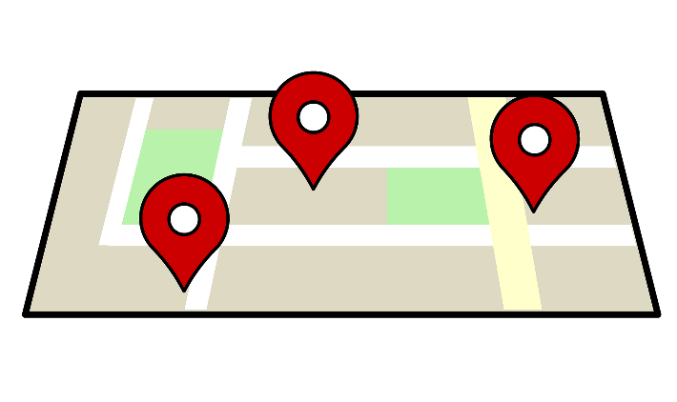

The Purpose of Evaluation

The purpose of evaluation is to measure and describe outcomes at scheduled points in time. Evaluation involves a variety of methods to measure whether the outcomes set for the learners have been achieved. It is essential to plan not only HOW a trainer will measure outcomes, but WHEN to do so.

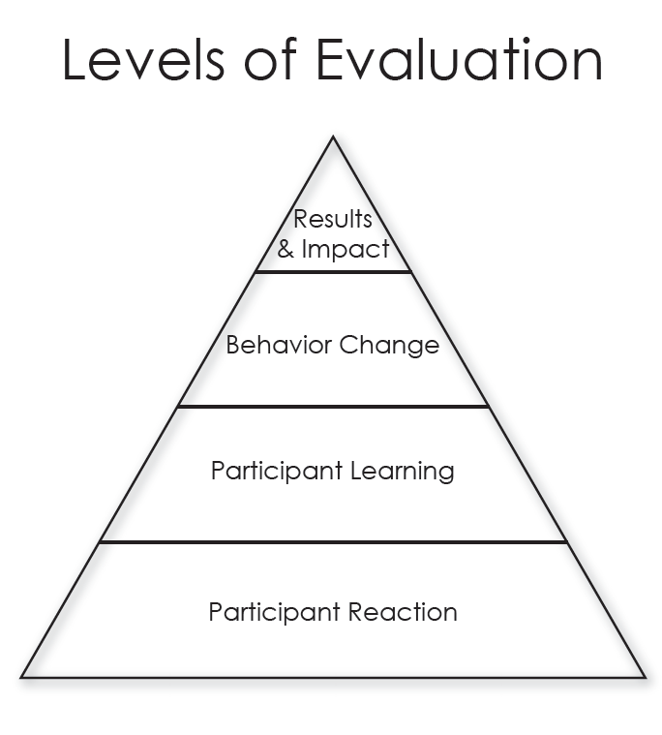

Participant Reaction (Level One)

This information is collected immediately following the training.

Questions asked at Level 1 are targeting how a learner feels about the training. This may include questions about the meeting location or how well the content and activities were received. These are all opinion related questions based on their feelings of being at the training.

Sample questions:
What did you like best about your training experience today?
On a scale of 1-5, how well organized was this training?
On a scale of 1-5, how helpful were the handouts?
On a scale of 1-5, how effective was your trainer?
Would you recommend this training to a colleague?

Methods:
The best methods for this level could be rating scale, yes/no questions or even some open-ended questions. You get more usable information asking a simple open-ended question that a yes/no question.
For example, Are you satisfied with the support materials vs. What did you like about the support materials? Did you enjoy the training session vs. What did you most enjoy about this training session?

Participant Learning (Level Two)

This information is collected immediately following the training.

Questions asked at Level 2 are targeting the actual content and skills covered in the train.
What did the individual actually learn? Here you are asking for concrete specifics about what they have learned.

Sample questions:
List three new strategies that you plan to implement in your classroom.
Provide three different examples of “open ended” questions.
Identify the four levels of evaluation
Describe three new activities that you will use to increase active movement throughout the day.
Identify three new items of content that were new and interesting to you.

Methods:
Methods for capturing information at Level 2 could include lists, descriptions, or comparisons.

Important: Level One (Participant Reaction) and Level Two (Participant Learning) evaluation data is captured at the end of the training session.

Behavior Change (Level Three)

This information is captured after a short period of time (i.e. possibly 4-8 weeks later) allowing the learner an opportunity to apply their new knowledge and skills back at the workplace. This level is inquiring about what teachers are doing differently back in their classroom after the training session. At this level you are measuring the use of the new knowledge and skills back on the job. This requires follow-up, depending on the topic, 4-8 weeks after the training to measure and determine change.

Methods:
Pre and Post list of materials in the science center
Pre and Post set of photos showing changes
Pre and Post observation narratives

*The key to this process is that it starts way back during the Needs Assessment so that the teaching staff can collect the baseline information from which to measure. This may involve a pre-assignment before the training. Teachers may be asked to send or bring photos of a certain center in their room or an inventory of the items in their outdoor play area.

Determining your follow up timeline in advance is important. Share with your trainees that they will receive a follow up survey in 6 weeks and to be on the lookout for it.

Early childhood professionals need time to practice and implement the new information

Results and Impact (Level Four)

Level Four evaluation measures the results and impact for children, families or for the overall program. That is the key to remember. If you can clearly demonstrate the level of impact a training has had on the overall program, a Director will feel they are receiving a return on their investment of professional development dollars.

This information is captured after a longer period (i. 3-6 months later) allowing the early childhood program an opportunity to apply what they have learned back at the workplace.

Sample questions:
Are children healthier, missing less days of school due to illness?
Has there been a drop in challenging behaviors since the children are now more actively engaged in cooperative play?
Are BMIs going down as a result of better nutrition and increased opportunities for exercise during the day?

Results and Impact is measured around 3-6 months post training depending on the type of content and how long it may take to measure the actual impact. Clear pre and post measures are needed and again must be thought through weeks prior to the actual face to face training.

The Training Improvement Process provides a look at how evaluation information can be used and asks the trainer specific questions regarding data that determines the training process, the trainer’s personal performance and cost effectiveness/justification of the training. Each of these areas is addressed within the four levels of evaluation.

How will the data be used?

How the evaluation information will be used directly impacts how the data will be analyzed and reported.
- Will data be used to determine the PROCESS→ how to improve the training itself and/or the outcomes for the participants?
- Will the data be used to determine the trainer’s PERSONAL PERFORMANCE→ how well the trainer facilitated the training?
- Level I and Level II Evaluation typically cover these two areas.

Will the data be used to determine the COST EFFECTIVENESS? → Can the training be justified to the administrators and/or to the funding source?
- Level III and Level IV Evaluation typically cover this area.
Analysis of data is important because those hiring you to train care about their ‘return on investment"” otherwise referred to as ROI.

Who will receive the results?

These individuals could be interested:
- Director/Administrator
- Session Participants
- Funding Source
- Families

What specific information will they need?
The information trainers need from an evaluation include:
- Participant Reactions
- Results and Impact
- Behavior Change
- Content Learned

What dissemination format?

What dissemination format will be most appropriate?
- Copies of Evaluations
- Narrative Report
- Graphs
- Summary of Evaluations

How to disseminate information?

How will the information be disseminated?
- Face-to-Face Presentation
- An emailed 1-2 page Summary of comments and calculated averages
- Written Narrative via email
- Hard-copy of Summary/Narrative; hand delivered/mailed
Review of Important Reporting Questions
Reporting questions that need to be asked and answered…
- Who will receive the results?
- What specific information will they need?
- What dissemination format will be most appropriate?
- How will the information be disseminated?

When you take the time to analyze your data, you then have the needed information to make refinements in your training style, the training content and the subsequent training delivery. The next part of the training improvement process is looking at the connection between evaluation and refinement of your training.

In this section we will look at helpful questions that will assist you in analyzing your training and determining the refinement that is needed to make it more effective for future participants.

Necessary Step: Post-Training Reflection

- If you are new to training, consistently engage in the post-training reflection exercise of analyzing information from participant evaluation forms and self-reflection.
- If you are an experienced trainer, but not taking the time or effort to do this post-training reflection exercise, it is time to implement this step in your workshop process.

The questions asked on participant evaluations are very important. They are the premise for getting the answers needed for reflection, analysis and, ultimately, refinement of that training. Likewise, the trainer should answer these same questions as part of his/her self-evaluation. This process of analysis; reflecting back, documenting observations and analyzing the level of effectiveness in implementing the training process, content, activities and of their own skills and knowledge as a trainer, should be a consistent part of a trainer’s workshop process.

Here are some important reflection questions a trainer should use to guide the development of their evaluation forms and for self-evaluation, post-training.

Each of these questions can be answered from two perspectives:
- From information summarized off participant evaluations.
- From the trainer’s own observations and experiences while conducting the training.

One very important message to get from this section on Refinement of Training is that not only do you need to get and pay attention to feedback from participants, you need to also self-analyze. Your own observations of participant’s actions, interactions and reactions during the workshop, as well as your observations of your own actions, interactions and content delivery throughout the training session provides much information on what went well and what needs to be refined to make the next workshop experience more effective.

Post-Training Reflection
...a series of questions to ask yourself:
- In what ways did the training process do what it was designed to do in regard to the Workplace Outcome and Training Outcomes?
- At what level of success did the content do what it was designed to do in regard to the Workplace Outcome and Training Outcomes?
- In what ways should the process be revised?
- In what ways should the content be revised?
- In what ways (if any) does the training content need to be revised due to:
- a need to align with revised Training Outcomes developed to meet federal, state, local regulations?
- a need to meet changes in recommended practices?
- If the training needs to be expanded, what are the reasons;
- need for additional content, time issues, etc.?
- If the training needs to be eliminated, what are the reasons;
- lack of need, cost effectiveness, duplication of content, etc.?

‘Series of Questions’ Tool

Using the ‘Series of Questions’ tool, you will
- Gain useful information
- Better analyze and determine future steps
- Better prepare for subsequent training
- Better meet your own goals as a trainer

You can customize this tool by adding questions you deem useful!

