Learning Log for Laugh to Learn
Date:_____________
Completed Learning Log will be uploaded at the end of the Application Activity in Part 8.

Part 1 – Welcome
Humor is a gift EVERYONE is born with, and it is also a SKILL that can be developed.
It is the goal of this training to…

you to release your inner humorist,

you to explore the benefits of using humor in your trainings, and

you to intentionally build humor into your trainings.

This training provides a rationale for you to use HUMOR as a training aid and asks you to practice with a variety of humor techniques before choosing one to develop more fully and demonstrate its use.

Training Outcomes:
- Describe the benefits and barriers to using humor in training
- List 4 types of humor strategies
- Develop and demonstrate a humor strategy for a training activity

Part 2 – What is humor?
After the pictures of David Letterman, the trampoline, and the puppy appear on screen at same time, pause the video and answer the following question before restarting…

What does humor mean to you?
Since we ask of participants to think creatively, be open to new ideas, and plan to use what they learn and then connect it to what they already know…using humor in a workshop is a great way to model how it helps promote these actions.
When you see the slide that has three of these four images, pause the video again and follow the instructions below the images.
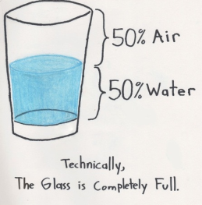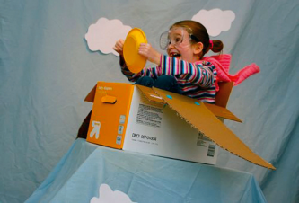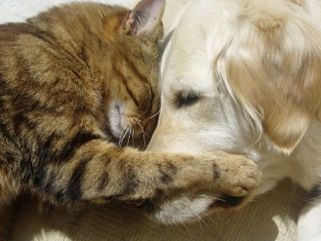

Write each of the following terms under the picture above that it best represents from the slide you currently have paused: optimism, new connections, creativity & play, and openness.
When you have finished doing so, restart the slide show.

Humor invites participants to make two important connections that help achieve training outcomes:
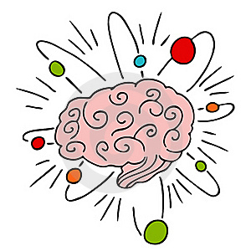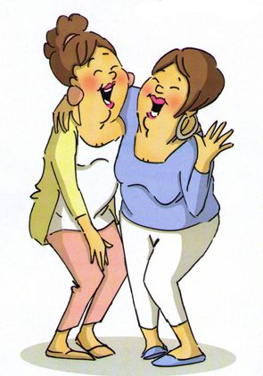
BRAIN CONNECTIONS (between new information and what they already know), and
SOCIAL CONNECTIONS (with their fellow participants)

Jokes or humorous stories should be used with great intent and they are actions that:
- Involve telling stories about _____________ _____________.
- Break down ____________ between ___________ and the content of the training.
- Require ________________ and __________________.
Humor can make an uncomfortable topic safe for participant engagement, as is demonstrated in the example of The Underwear Story and Attachment.

Part 3 - Reach Out and Touch
Watch the “Reach Out and Touch” video and respond to the following three questions. After viewing the video and answering the questions, proceed to Part 4: Developing a Humorous Story.

- How is the presenter’s humorous story about texting her husband relevant to capture attention and build interest?
- What about the humorous story reduces the anxiety that might be created in someone by asking her/him to text someone she/he loves and cares about to let that person know how she/he feels?
- What did you notice about the structure of this story?

Part 4 - Developing a Humorous Story (to use in a training):
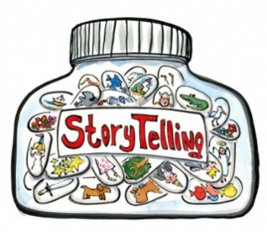

STORYBOARDING is a helpful organization tool.

- Set the __________ from the storyteller’s perspective.
- Add ____________ and _________ (feel free to embellish).
- Describe the ________________.
- Deliver the _________________.

The best stories, of course, are those we’ve actually lived, though we can ask to “borrow” funny stories from others/other sources.

Part 5 - Interest – Retention – Attention
Effective trainers build up the IRAs in their trainings:
- It is critical to first capture the _______________ of your participants.
- You must also promote their _____________ through the use of relevant content and engaging learning experiences.
- When sensory memory and working memory have done their jobs, only then can there be ________________ of the skills and knowledge into long-term memory.
To respond to the Primacy/Recency effect, trainers must weave new beginnings and endings throughout their trainings.
The brain learns best when it connects to the W______ I__ I__ F____ M__ to foster intrinsic motivation. F-U-N can help add this to the training.
The VON RESTORFF effect describes the brain’s need for novelty and “colorful” items that measurably increase emotional arousal and attention in the brain. Colorful items can be something surprising, odd, frightening (but not too frightening), or funny.
We tend to laugh even more when we watch other people laughing…and while the Carol Burnett Show “Gone With the Wind” example from the video won’t resonate with younger participants, the incorporation of a contemporary “pop” culture phenomenon into a training topic in a humorous way (perhaps with a COLORFUL ITEM) can get the whole group laughing at once.
After reviewing the Outdoors Pokemon Go/Facebook example in the slide show, add your own Pop Culture Connection to the discussion thread by LEAVING A REPLY in the comment box that includes a description of your example along with a link (if applicable) to a photograph, video, article, or web site.

Part 6 - What Humor Does
Brain research shows that the fear of threat and high stress impede learning.
Mirthful and authentic laughter changes brain chemistry and replaces distress (negative stress) with eustress (positive stress), and allows adult learners to open up for learning to occur.
Humor can transform an awkward and potentially stressful situation into an enjoyable experience that brings people together. The key to this is the use of self-deprecating humor (making fun of yourself) when something goes wrong or takes an unexpected turn during a training.
Therefore, experiencing pleasure early in a training can help positively guide participants’ emotions to tell them:
- How _________________ the topic is,
- Whether or not they want to ___________ it,
- Whether or not they believe information they hear from you is _________ , and
- How _________ they should __________________ it.
All that we hear in order to learn passes through the brain’s limbic system (emotional center) BEFORE it can reach the cerebrum or “thinking” part of the brain.
You can also align humor and content into frequent BRAIN BREAK activities to divide trainings into shorter sections that create new beginnings and new endings for novelty and attention.

Part 7 - Humor as a Training Aid
How we use humor as a training aid can create some potential barriers to effective training.
Trainers can easily avoid these obstacles by:
- K________ I__ R________ - Don’t just tell jokes and try to be a stand-up comedian. The meaningful and intentional use of content-based humorous stories, actual events, clever pictures and props all will capture the attention of and engage your audience of participants.

- P__________ , P___________ , P__________ ! - The use of humor must be deeply intentional with a specific, content-related purpose that is planned in advance and rehearsed. It needs to be reflected upon, revised, and worked on, just like any other skill.

- Stay a__________________ - Avoid derogatory humor that is offensive. Age, race, gender, sexuality, ethnicity, ability, etc., are just some of the demographics you should be very mindful of when planning to use humor.

Use the space below to note any other potential barriers to using humor that you are aware of along with ways to remove or avoid them.

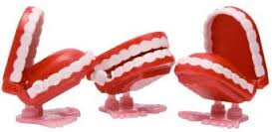

Funny Props
Pause the video at the beginning of this section and record the following in the space below…
What props have you used (or seen used) in training and how were they used?
Props are tangible, recognizable, symbols of ideas and concepts that are most effective when integrated throughout the training to repeat and reappear as a reminder.
Props can be as simple as household objects used as an analogy that cause participants to think creatively and laugh together.
On the lines beside each of the four images below, complete the analogy with an appropriate phrase.
Being a trainer is like being a:
because ________________________________________

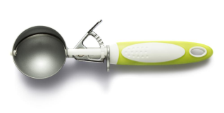 because _________________________________________

because __________________________________________
because ___________________________________________

Watch as much of the Imagination Juice video as you can and respond to the following three “What did you notice?” questions:
(NOTE: If the video skips ahead to the three questions screen before playing in its entirety, restart the video and hover your cursor over the video screen to reveal the gray, blue and black video toolbar at the bottom. Then try sliding the circular video progress button over to the right a bit and release it to see if you can get the video to continue playing all the way through.)

- How does the telling of this story engage participants?

- How does the simple prop add humor?

- How could you add a simple, funny prop to a brainstorming activity?

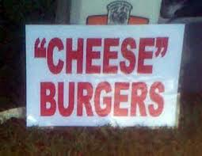

Cartoons and Funny Pictures

Pause the video at the beginning of this section as you answer the following three questions, then restart it as you follow along below them…

- What kinds of pictures make you laugh?

- Who is your favorite cartoon character? Do you have a favorite comic strip? What makes them funny to you?

- If you have used funny pictures and cartoons as training aids, where did you find them?

They are best used with an activity or discussion built around them, or to punch-up the punchline of a humorous story.
Choose images that are O__________ - E_____________ (inviting participants to add their own captions), spark D________________ , or require a S__________ L_________.
Avoid the temptation to simply flash them up on the screen as an afterthought. Plan their use to help you get more bang for your humor buck!
As a credentialed trainer, you are required to observe all intellectual property copyright and patent laws, so, either create your own, only use images that are in the public domain, or obtain permission to use copyrighted material.

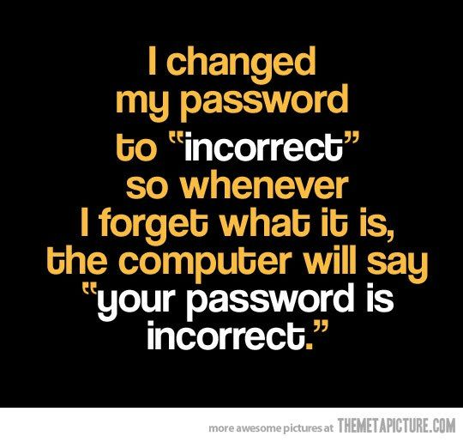

Funny Quotes
How can funny quotes contribute to building up the I-R-A cycle discussed in Part 5?
A M_______ combines the visual imagery of a picture with cleverly chosen written words to create a great humorous discussion starter to explore and/or reinforce a concept.
These are all over the internet, and in addition to finding pre-made ones, you can also use online meme generators or someecards.com to create your own.
Be sure to check the TERMS OF SERVICE for these internet resources to make sure you operate within legal and acceptable use guidelines.

Write a caption or word bubble for the someecard shown below.

Humorous Games
The game called FORTUNATELY… uses “turnabout humor” to transform negative situations into positives, and trains people to see the silver lining in even the most difficult of circumstances.

Pause the video, then write three negative/positive statements in the style of the Fortunately… game in the spaces below.

- ________________________________________ , but FORTUNATELY…

_______________________________________

- ________________________________________ , but FORTUNATELY…

_______________________________________

- ________________________________________ , but FORTUNATELY…

_______________________________________

Adapting this classic “bit” from Dave Letterman’s late night talk show might go over well as a game for older participants who remember his program….

Top 10 things a baby would say about Circle Time

1.
2.
3.
4.
5.
6.
7.
8.
9.
10.
Before moving on to the Application Activity in Part 8, check back through your notes in the Learning Log to complete your TOP TEN list (4 + 6 = 10, right????) below:
TOP FOUR Humor “Bits” I Have Used (or Plan to Use) in Trainings
1.

2.

3.

4.
TOP SIX Benefits in Using Humor As A Training Aid
5.

6.

7.

8.

9.

10.

Part 8 - Application Activity Planning Worksheet
Choose one of the humor strategies discussed in this training to develop one of your own to use in a training or describe one that you have already used in the past. After completing this worksheet, you will enter this information into the “quiz” windows online.
Please choose from:
- a humorous story
- a funny prop activity
- cartoons/funny pictures and quotes (memes)
- a humorous game
Training topic for which this humor strategy will be (or was) used:
Your objective(s) in using this strategy:
Type of humor strategy:
Description of activity:
Materials needed (Powerpoint slides, props, game materials, etc.):
If you have already had the opportunity to use this strategy with an audience, briefly describe their response to it and any revisions you would make to the activity:
The final item of this Application Activity “quiz” (as it appears online) is to upload a copy of this completed Learning Log for instructor review.
Laugh to Learn Course References:
Tamblyn, D. Laugh and Learn: 95 ways to use humor for more effective teaching and training. New York: Amacom, 2003.
Greenberg, David. How to use humor in your presentations. Simply Speaking, Inc. http://www.simplyspeakinginc.com
Tamblyn, D. & Weiss, S. The Big Book of Humorous Training Games. New York: McGraw Hill, 2000.
Biech, Elaine. Training for Dummies: Adding Humor to Training. Link to article: Adding Humor To Training

