**Co-Teaching Approaches for CT4GC**

**Team Teaching**

**Approach:** Both teachers are actively involved in the instruction of the lesson and classroom management. From an observer’s point of view, there is no clear leader since both teachers are equally sharing instruction. Students see both teachers as “equal”.

**Amount of Planning:** This approach requires a high amount of planning between the team members. It is the most complex of the approaches due to individualized teacher styles and content knowledge.

**When to Use**: This approach is energizing, especially when providing different learning strategies to students. Used when presenting multiple ways of problem solving or role modeling “think alouds”. Effective when introducing a new topic or concept that may appear difficult to students.

**Challenges of this approach:** Both teachers must have strong content knowledge of the subject and/or learning strategies. Significant planning time is needed. This approach demands the greater amount of trust and confidence between the teachers.

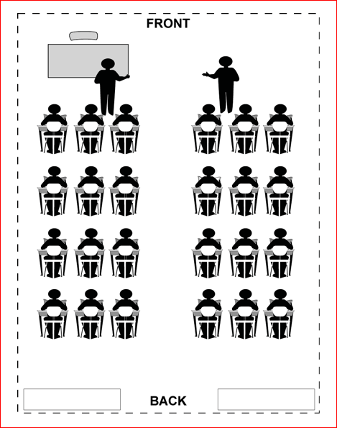 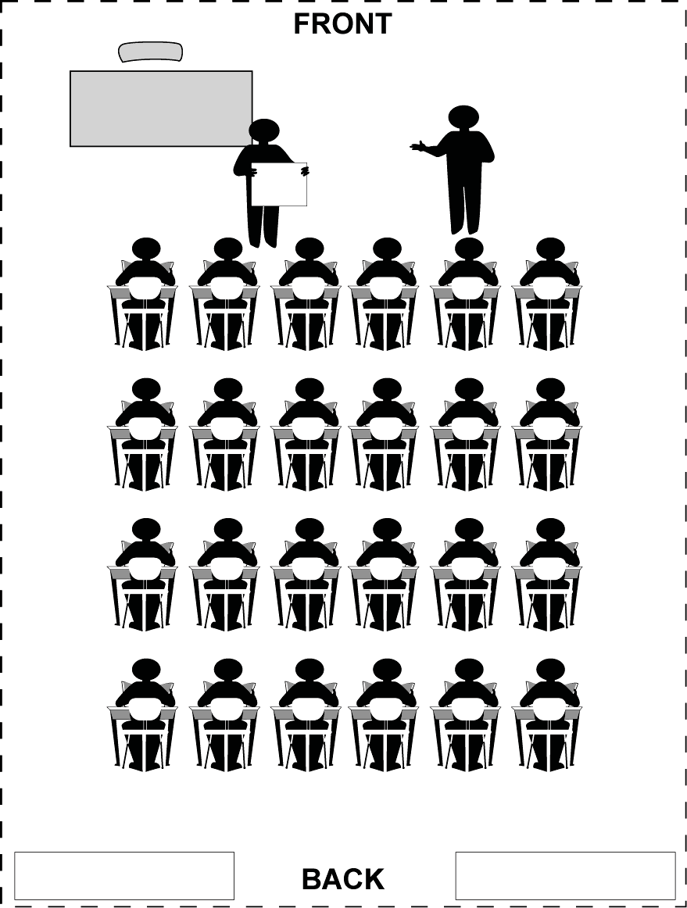

**Example of Implementation in the Classroom:** Often the most understood, the approach requires a great deal of planning.

One teacher may present the content while the other is modeling notetaking on a board and discussing its purpose.

One teacher may lead discussion of an upcoming experiment while the other member is demonstrating the use of materials needed to complete the work.

One teacher may be working through a math problem on the board while the other member discusses through questioning.

Classroom Set-Up*