**Co-Teaching Approaches for CT4GC**

**Station Teaching**

**Approach:** Teachers divide content and place students in equally sized groups. Groups rotate from station to station in a specific amount of time. Each teacher then teaches a portion of the material and repeats for subsequent groups. A third station can be added to allow for independent work, technology access or peer tutoring.

**Amount of Planning:** This approach requires a medium amount of planning since content needs to be divided, groups identified and expectations for all stations determined. For some subject content, planning may be significant.

**When to Use**: This approach is effective when content is complex, but not hierarchical. It allows teachers to closely monitor student understanding and to work with every student in the class. Secondary teachers may use more frequently in a block setting.

**Challenges of this approach:** Teachers must have adequate content knowledge in order to provide equally effective instruction. Classroom expectations regarding station rotation and independent work are necessary. Teachers must plan for noise level and determine physical space needed for each station.

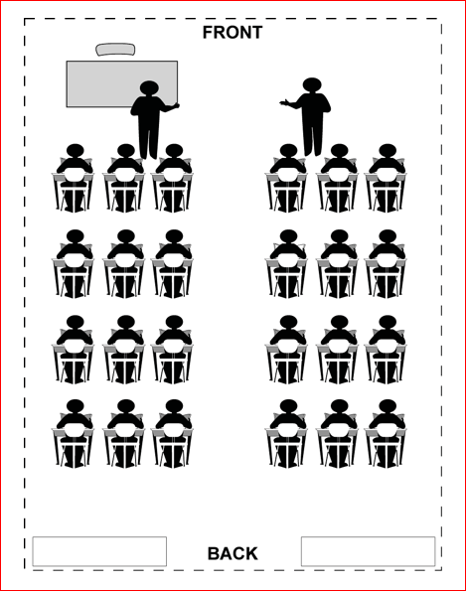

**Example of Implementation in the Classroom:** Results in fewer behavior issues due to higher student activity and engagement.

In a social studies class, students may exam the geography, economy and culture of a specific region or country.

In language arts, one teacher may be reviewing a piece of literature, the other teacher focusing on specific elements and the students are writing at an independent station.

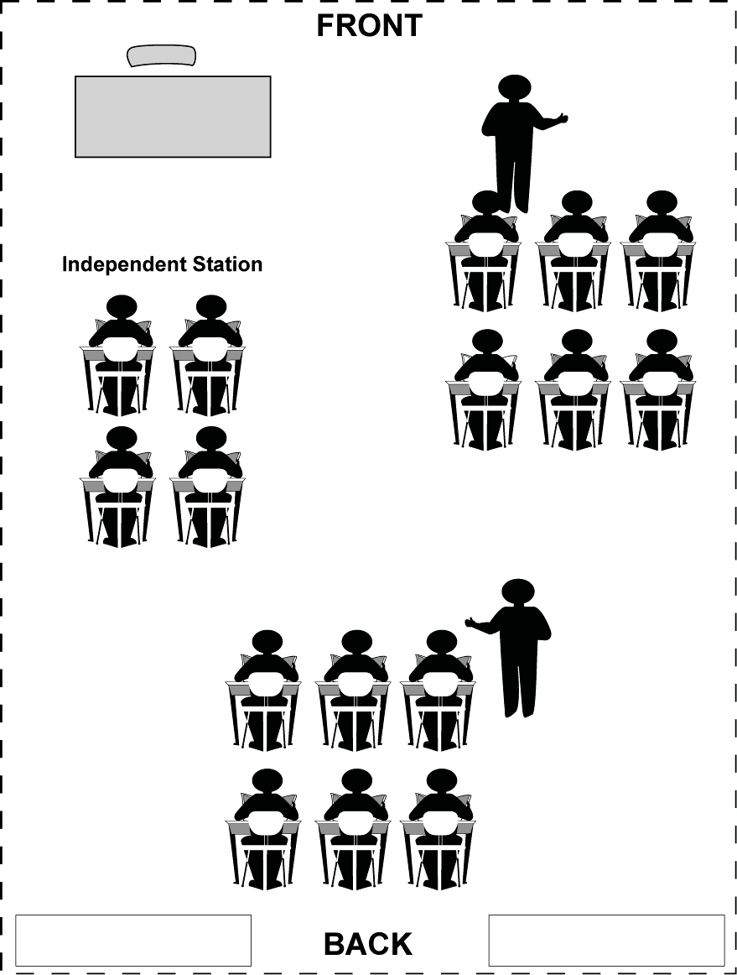

Classroom Set-Up*