**Co-Teaching Approaches for CT4GC**

**Parallel Teaching**

**Approach:** Each teacher instructs half of the students on the same instructional materials using similar teaching techniques. Allows for greater student discussion, fewer behavior issues and more teacher supervision. Both groups come together for reflection.

**Amount of Planning:** This approach requires planning since both teachers need to be familiar with content and student expectations.

**When to Use**: Excellent approach for re-teaching drill and practice or test review. This approach allows for greater student interaction due to small group size.

**Challenges of this approach:** Teachers must have adequate content knowledge and pedagogical skills to provide equally effective instruction. Identifying appropriate physical space needs to be determined prior to use of this approach. Teachers need to consider noise level and student distractibility.

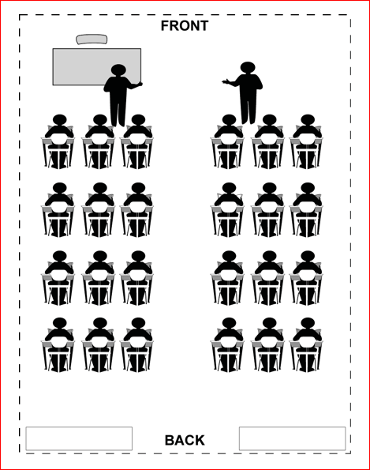

**Example of Implementation in the Classroom:** Effective when a lower teacher-student ratio is needed to improve instructional outcomes.

In a language arts class, students may review essential parts of a story, share alternative endings or be involved in a vocabulary review.

In a math or science class, students may prepare for an upcoming test or review previous work. This approach is works well when discussing the steps necessary in problem solving or experimental design.

In a social science class, one group of students may be looking at information from a business point of view while the other is viewing the same information from the view of an environmentalist. Students would then debate the issue.

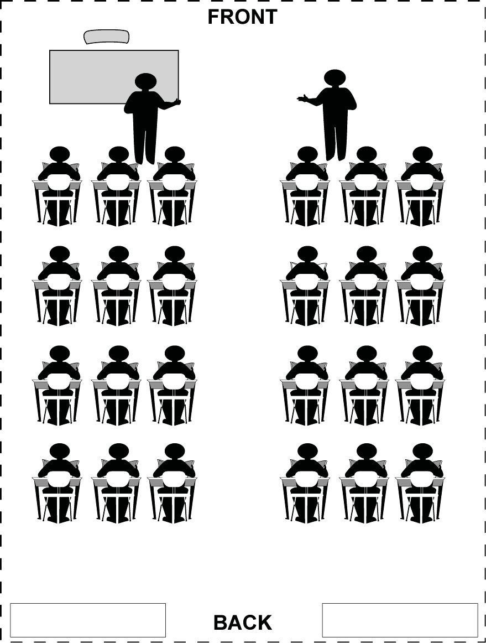

Classroom Set-Up*