Co-Teaching Approaches for CT4GC

One Teach, One Observe
Approach: Used when one teacher has the primary responsibility of instruction while the other is gathering specific observational information. The key is the observation is on a specific behavior(s). Afterward, the teachers should analyze information together. This approach is a deliberate part of instruction and not just a teacher moving around the classroom to monitor student behavior.
Amount of Planning: This approach requires a low amount of planning, however the behavior observed is specific and a system for gathering data developed.
When to Use: This approach is most often used in new co-teaching situations or when monitoring student progress is necessary. Also used when observing a student(s) for the recommendation of additional services.
Challenges of this approach: Teachers need to know how to collect and analyze data. Data disaggregation may require additional planning time.

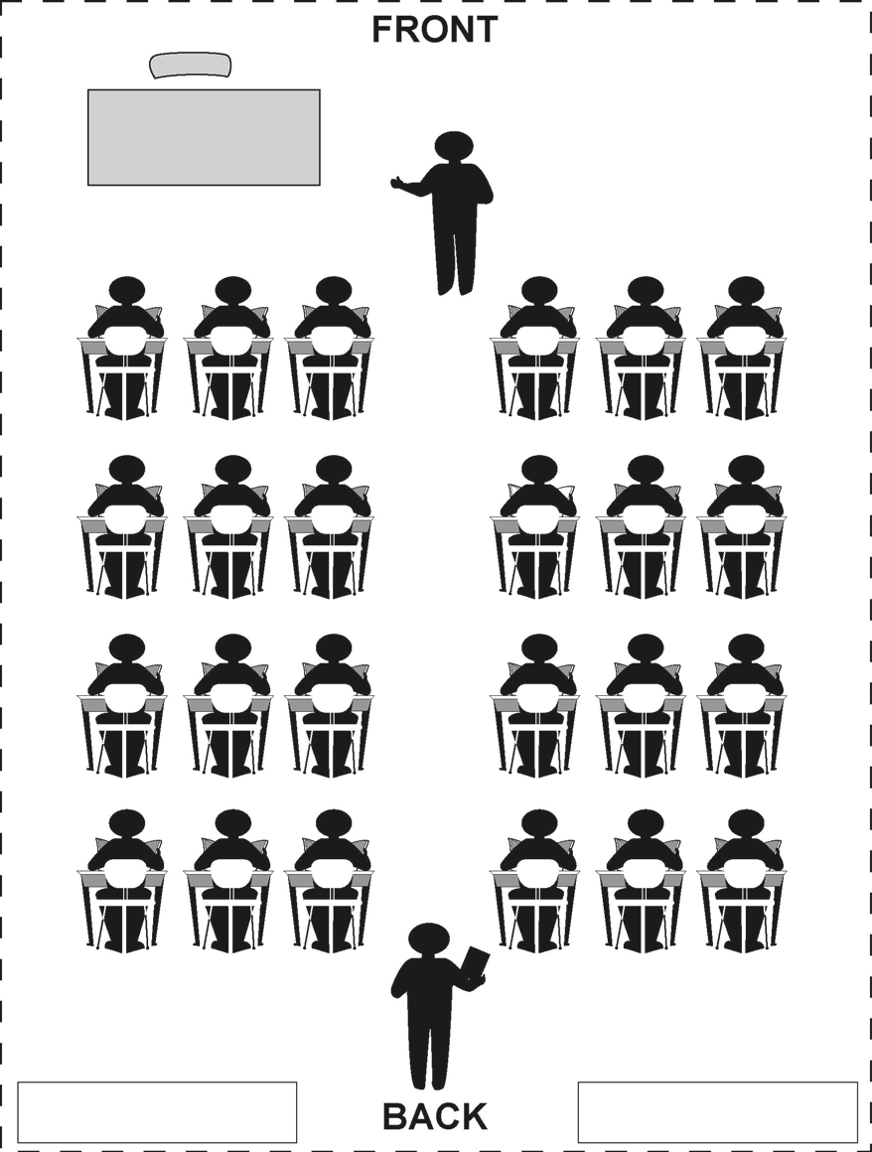
This approach is NOT: One teacher moving around the classroom to insure all students have needed classroom materials, i.e. pencil, paper or textbook.
One teacher instructing a small group of students without specific data gathered.

Classroom Set-Up*

