Co-Teaching Approaches for CT4GC

One Teach, One Assist
Approach: One teacher does most of the instruction while the other assists students in their work, monitors classroom behaviors or asks questions as he/she observes student work. Often the most over used approach because it makes few demands on both teachers.
Amount of Planning: This approach requires little planning by the co-teaching team since instruction is the primary responsibility of ONE teacher.
When to Use: Used when co-teaching teams are getting to know each other. Used effectively when one teacher has expertise in a specific subject. May be needed when students are learning a new process and close monitoring is needed.
Challenges of this approach: If approach is often used, students may view one teacher as the “real” teacher and the other as an assistant. Students may expect one to one assistance from observing teacher.

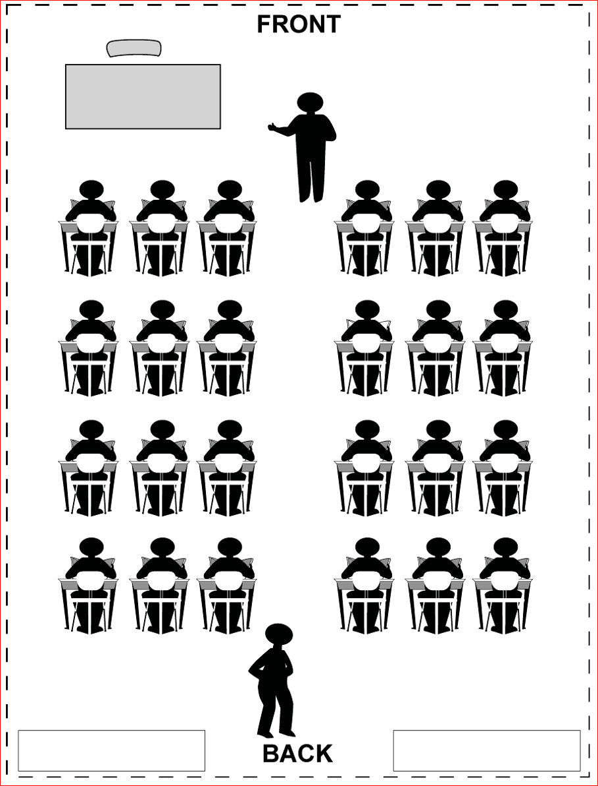
Classroom Set-Up*

Example of Implementation in the Classroom: Each teacher should have an opportunity to lead instruction and drift.
In math class, when steps of long division are being taught and students need monitoring to quickly resolve confusion.
Students are completing notes on a subject where accuracy and task completion are necessary.

